Adjacent Complementary Angles

Definition
# Source: AI Source: Provided by: [Data Path: Persons Table -> ID Column: 1, Name_En Column: Motasem Essam] -> From: [ChatGPT] on [7/25/2026]

Adjacent Complementary Angles are two adjacent angles whose measures add up to exactly ${90}^{∘}$.
They share a common vertex and one common side, their interiors do not overlap, and together they form a right angle.
Therefore:
$$\boxed{m∠1+m∠2={90}^{∘}}$$

Simple Definition
# Source: AI Source: Provided by: [Data Path: Persons Table -> ID Column: 1, Name_En Column: Motasem Essam] -> From: [ChatGPT] on [7/25/2026]
Adjacent Complementary Angles are two adjacent angles whose measures have a sum of ${90}^{∘}$.

Conditions
# Source: AI Source: Provided by: [Data Path: Persons Table -> ID Column: 1, Name_En Column: Motasem Essam] -> From: [ChatGPT] on [7/25/2026]
Two angles are adjacent complementary angles when they satisfy all of the following:
1. Common Vertex
Both angles have the same vertex.
For example:
$$∠ABC$$
and
$$∠CBD$$
have the common vertex $B$.
2. Common Side
They share one side:
$$\vec{BC}$$
3. Non-Overlapping Interiors
The interiors of the two angles do not overlap.
4. Their Sum Is ${90}^{∘}$
$$\boxed{m∠ABC+m∠CBD={90}^{∘}}$$
5. Together They Form a Right Angle
Their two non-common sides form a ${90}^{∘}$angle.

Example
# Source: AI Source: Provided by: [Data Path: Persons Table -> ID Column: 1, Name_En Column: Motasem Essam] -> From: [ChatGPT] on [7/25/2026]
Suppose:
$$m∠ABC={30}^{∘}$$
and:
$$m∠CBD={60}^{∘}$$
Then:
$${30}^{∘}+{60}^{∘}={90}^{∘}$$
Therefore, they are adjacent complementary angles.
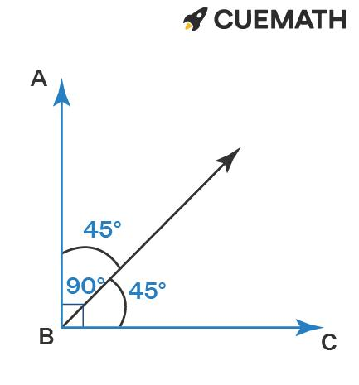
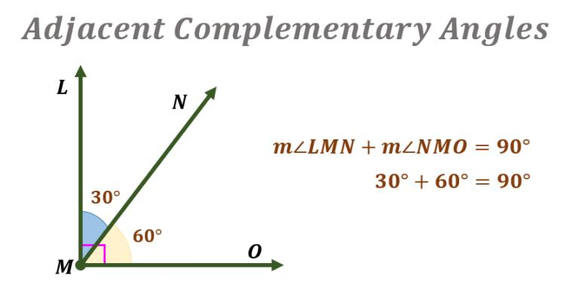
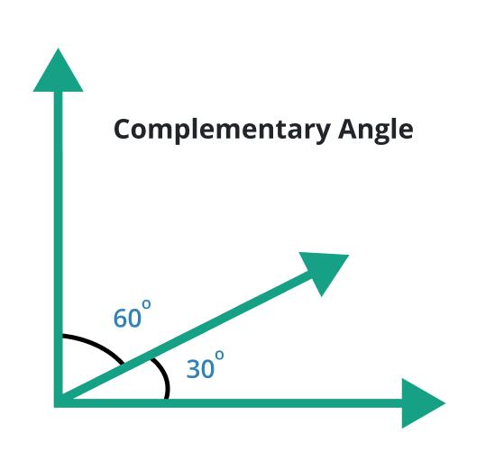
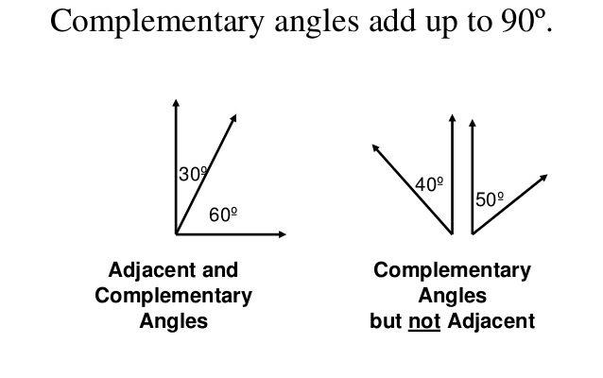
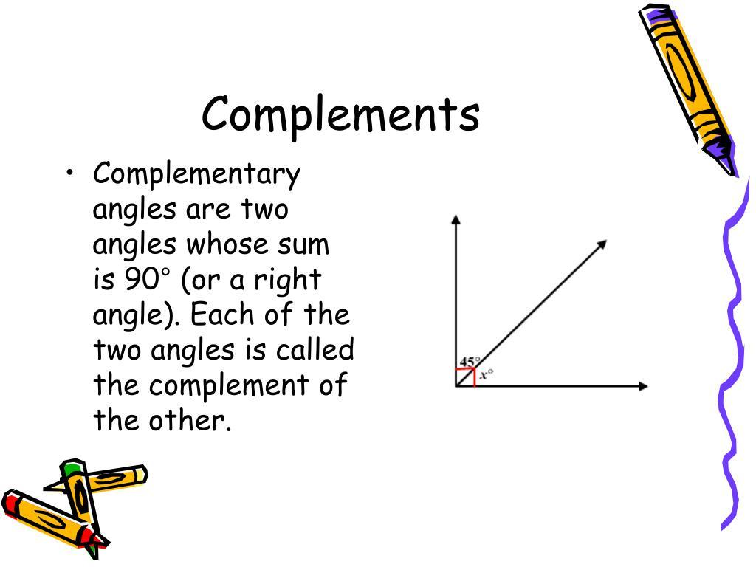

Different Examples
# Source: AI Source: Provided by: [Data Path: Persons Table -> ID Column: 1, Name_En Column: Motasem Essam] -> From: [ChatGPT] on [7/25/2026]
Example 1: ${30}^{∘}+{60}^{∘}$
$${30}^{∘}+{60}^{∘}={90}^{∘}$$
Both angles are acute.
Example 2: ${45}^{∘}+{45}^{∘}$
$${45}^{∘}+{45}^{∘}={90}^{∘}$$
Both angles are acute and equal.
Example 3: ${20}^{∘}+{70}^{∘}$
$${20}^{∘}+{70}^{∘}={90}^{∘}$$
The angles are complementary.
Example 4: ${10}^{∘}+{80}^{∘}$
$${10}^{∘}+{80}^{∘}={90}^{∘}$$
The angles are complementary.

Finding an Unknown Angle
# Source: AI Source: Provided by: [Data Path: Persons Table -> ID Column: 1, Name_En Column: Motasem Essam] -> From: [ChatGPT] on [7/25/2026]
If two adjacent angles are complementary and one angle measures $x^{∘}$, then:
$$x+θ={90}^{∘}$$
Therefore:
$$\boxed{θ={90}^{∘}-x}$$
Example
If:
$$m∠A={35}^{∘}$$
then:
$$m∠B={90}^{∘}-{35}^{∘} \\ \boxed{m∠B={55}^{∘}}$$
So:
$${35}^{∘}+{55}^{∘}={90}^{∘}$$

Complementary Angles Must Be Acute
# Source: AI Source: Provided by: [Data Path: Persons Table -> ID Column: 1, Name_En Column: Motasem Essam] -> From: [ChatGPT] on [7/25/2026]
For two nonzero complementary angles:
$$A+B={90}^{∘}$$
Since each angle is positive:
$$0^{∘}<A<{90}^{∘}$$
and:
$$0^{∘}<B<{90}^{∘}$$
Therefore, both angles are normally acute angles.
For example:
$${25}^{∘}+{65}^{∘}={90}^{∘}$$
Both ${25}^{∘}$and ${65}^{∘}$are acute.
Degenerate zero-degree cases are excluded in ordinary angle classification.

Adjacent Complementary vs Adjacent Supplementary
# Source: AI Source: Provided by: [Data Path: Persons Table -> ID Column: 1, Name_En Column: Motasem Essam] -> From: [ChatGPT] on [7/25/2026]
These two types are easy to confuse.
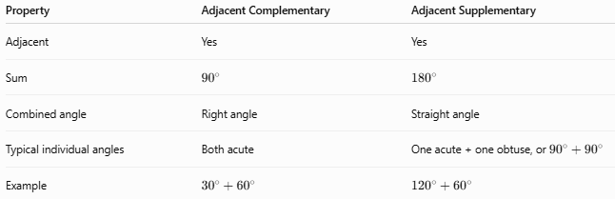
Property | Adjacent Complementary | Adjacent Supplementary
Adjacent | Yes | Yes
Sum | $${90}^{∘}$$ | $${180}^{∘}$$
Combined angle | Right angle | Straight angle
Typical individual angles | Both acute | One acute + one obtuse, or ${90}^{∘}+{90}^{∘}$
Example | $${30}^{∘}+{60}^{∘}$$ | $${120}^{∘}+{60}^{∘}$$
Thus:
$$\boxed{\text{Complementary}→{90}^{∘}}$$
while:
$$\boxed{\text{Supplementary}→{180}^{∘}}$$

Adjacent Complementary vs Linear Pair
# Source: AI Source: Provided by: [Data Path: Persons Table -> ID Column: 1, Name_En Column: Motasem Essam] -> From: [ChatGPT] on [7/25/2026]
An adjacent complementary pair forms a right angle:
$$A+B={90}^{∘}$$
A linear pair forms a straight angle:
$$A+B={180}^{∘}$$
Therefore, an ordinary pair of adjacent complementary angles cannot be a linear pair.

Important Relationship with Right Angles
# Source: AI Source: Provided by: [Data Path: Persons Table -> ID Column: 1, Name_En Column: Motasem Essam] -> From: [ChatGPT] on [7/25/2026]
A right angle can be divided into two adjacent complementary angles.
For example:

B
/
/
/
●──────── C
A
If:
$$m∠AOB={40}^{∘}$$
and:
$$m∠BOC={50}^{∘}$$
then:
$${40}^{∘}+{50}^{∘}={90}^{∘}$$
So the two angles together form:
$$\boxed{\text{A right angle}}$$

Special Case: Equal Adjacent Complementary Angles
# Source: AI Source: Provided by: [Data Path: Persons Table -> ID Column: 1, Name_En Column: Motasem Essam] -> From: [ChatGPT] on [7/25/2026]
If the two adjacent complementary angles are equal:
$$A=B$$
and:
$$A+B={90}^{∘}$$
then:
$$2A={90}^{∘} \\ \boxed{A=B={45}^{∘}}$$
Thus, two adjacent ${45}^{∘}$angles are a special case of adjacent complementary angles.

Important Distinction
# Source: AI Source: Provided by: [Data Path: Persons Table -> ID Column: 1, Name_En Column: Motasem Essam] -> From: [ChatGPT] on [7/25/2026]
The word adjacent describes the position/relationship of the angles.
The word complementary describes their combined measure.
Therefore:
$$\boxed{\text{Adjacent}=\text{geometric relationship}} \\ \boxed{\text{Complementary}=\text{measure relationship}}$$
Two complementary angles do not have to be adjacent.
For example, two separate angles measuring ${35}^{∘}$and ${55}^{∘}$are complementary even if they are located far apart.

Key Formulas
# Source: AI Source: Provided by: [Data Path: Persons Table -> ID Column: 1, Name_En Column: Motasem Essam] -> From: [ChatGPT] on [7/25/2026]
Degree form:
$$\boxed{A+B={90}^{∘}}$$
Unknown angle:
$$\boxed{B={90}^{∘}-A}$$
Radian form:
$$\boxed{A+B=\frac{π}{2}}$$

Key Points
# Source: AI Source: Provided by: [Data Path: Persons Table -> ID Column: 1, Name_En Column: Motasem Essam] -> From: [ChatGPT] on [7/25/2026]
- Two adjacent angles share a common vertex.
- They share one common side.
- Their interiors do not overlap.
- Their measures add to exactly ${90}^{∘}$.
- Together, they form a right angle.
- Nonzero complementary angles are both acute.
- ${45}^{∘}+{45}^{∘}={90}^{∘}$is a special equal-angle case.
- Complementary angles do not necessarily have to be adjacent.
- Adjacent complementary angles are different from a linear pair.

Conclusion
# Source: AI Source: Provided by: [Data Path: Persons Table -> ID Column: 1, Name_En Column: Motasem Essam] -> From: [ChatGPT] on [7/25/2026]
Adjacent Complementary Angles are two adjacent angles that divide a right angle into two parts. Their measures satisfy:
$$\boxed{m∠1+m∠2={90}^{∘}}$$
For example:
$$\boxed{{30}^{∘}+{60}^{∘}={90}^{∘}}$$
Thus, their defining combination is adjacency + a ${90}^{∘}$total.

